

Faculty oF information AND COMMUNICATION technology
PRINCIPLES OF STRUCTURED PROGRAMMING PROG103
Title : Structured Digital Solution for Public Service
(GUI Based Application)
Due Date : Week 11
Semester/Year : 2/1
Lecturer : Mr. Elijah Fullah
Class : BIT1201
NO. | Name | Surname | ID | SIGN | MARKS
1 | Clifford Joshua | Jones | 905005820
2 | JANE SARAH | BANGURA | 905005883
3 | ISMATU | KAMARA | 905005885
Academic Honesty Policy Statement
We, hereby attest that contents of this attachment are my own work. Referenced works, articles, art, programs, papers or parts thereof are acknowledged at the end of this paper. This includes data excerpted from CD-ROMs, the Internet, other private networks, and other people’s disk of the computer system.

Submitting Person’s Signature : Date: …………………..
(If submission is for a group work, all students’ names MUST appear above and put down their signatures here)

LECTURER’S COMMMENTS/GRADE: | for office use only upon receive  Remark  DATE :  TIME :  RECEIVER’S NAME :

TABLE OF CONTENT
INTRODUCTION…………………………………………………………PAGE 3
PROJECT RATIONALE……………………………..…….……………PAGE 4
CONCLUSION…..…………………………………….……………’……PAGE 10
REFERENCES….…………………………………………..………….…PAGE 11

INTRODUCTION
The AuraClinic Healthcare Management System is a fully featured, GUI-based desktop application developed in Python using the tkinter framework. It was built to address real-world inefficiencies in patient registration, appointment scheduling, and healthcare record management commonly encountered in small to medium-sized clinics.
The system replaces paper-based and error-prone manual processes with a clean, navigable interface. After a secure login, staff members can register and manage patient records, book appointments with integrated time-slot availability checking, view and update appointment records, and search patients using multiple filter criteria. The project demonstrates the practical application of structured programming principles including modular design, object-oriented encapsulation, data validation, and event-driven programming.
This report covers the problem addressed, the system’s design and architecture, the structured programming principles applied, and its alignment with the United Nations Sustainable Development Goals (SDGs).

PROJECT RATIONALE
Problem description
Healthcare facilities often struggle with managing patient records and appointments. Manual systems are prone to human error, lack transparency, and make it difficult to track cancellations or reschedules. In Sierra Leone, where small clinics may not have advanced hospital management systems, a lightweight solution is essential. This project provides a digital platform where patients can be registered, appointments booked, rescheduled, or cancelled, and all records stored securely in a database. The system reduces administrative workload and improves patient satisfaction by ensuring appointments are clear and accessible.

System Overview and Architecture
When the application starts, the user is presented with the AuraClinic login window. This window has a split-panel layout with the clinic illustration on the left and the login form on the right. The form accepts a username and password and validates them against a built-in credential dictionary. Three demo accounts are provided for testing: admin with password admin123, doctor with password doc2025, and nurse with password nurse2025. On a successful login the login window is hidden and the main application shell is opened.
The main application shell is a full-screen window divided into three persistent zones. The header runs across the top and displays the clinic branding image, the system title, and a live digital clock that updates every second. The sidebar runs down the left side and contains navigation buttons for the four main pages as well as a Log-out button. The content pane fills the remaining space on the right and is dynamically replaced each time the user clicks a navigation button.
The four pages of the application are described below.
- Register Patient: This page presents a two-column data entry form at the top. The fields are Patient ID, which is automatically generated and read-only, Full Name, Age, Gender, Phone Number, Address, Email, Blood Group, Medical Condition, and Date Registered. Below the form are four action buttons labelled Save Patient, Update, Delete, and Clear. Beneath those buttons is a scrollable Patient List table that shows all registered patients. Clicking any row in the table automatically fills the form fields above, making it easy to update or delete an existing record.
- Book Appointment: This page is split into a left panel and a right panel. On the left, the user enters a Patient ID and clicks Search, which automatically fills in the patient’s name and phone number. The user then selects a department, which updates the Doctor dropdown to show only the doctors available in that department. Additional fields allow the user to choose an Appointment Type, Date, Time, and an optional Reason. On the right panel, an interactive time-slot grid displays all available slots for the chosen doctor and date. Slots that are already booked appear in red and are disabled. The selected slot is highlighted in teal. A live Appointment Summary below the grid reflects every selection the user has made before they confirm the booking.
- Appointment Records: This page shows a search filter panel at the top where the user can filter by keyword, date range, doctor, and appointment status. Below the filters is a scrollable results table listing all appointments with their ID, patient ID, full name, doctor, date, time, and status. When the user selects a row, an Appointment Details card at the bottom of the page fills in with the full record. Four action buttons sit beneath the details card. View Details opens a popup with the complete appointment information. Edit Appointment opens a dialog where the doctor, date, time, type, status, and notes can all be changed. Cancel Appointment marks the record as Cancelled. Mark as Completed marks the record as Completed. The status badge changes color automatically: teal for Booked, green for Completed, and red for Cancelled. An Appointment Summary panel to the right of the details card shows the total count of all appointments broken down by status. The entire page is wrapped in a scrollable canvas so the details area is always reachable even on smaller screens.
- Search Patient: This page provides the most comprehensive filtering in the system. The user can search by Patient ID or Full Name using a keyword, and can additionally filter by Full Name, Phone Number, Gender, Blood Group, and a date registered range. The results are displayed in a Review table showing Patient ID, Full Name, Age, Gender, Phone Number, Blood Group, and Date Registered. An Export button in the results area allows the user to save the current results to a CSV file using a standard file-save dialog.

All four pages share a common in-memory data layer. Two module-level lists, named PATIENTS and APPOINTMENTS, hold the application data and are pre-seeded with five sample records each. Auto-increment helper functions generate new Patient IDs and Appointment IDs automatically. Because all pages operate on the same shared lists, a patient added on the Register Patient page is immediately available for lookup on the Book Appointment page without any additional steps.

SDG Relevance
The AuraClinic system aligns directly with two United Nations Sustainable Development Goals.

SDG 3 — Good Health and Well-Being: By digitizing patient registration and appointment scheduling, the system reduces administrative errors and prevents double bookings. The appointment status tracking and the summary statistics on the Appointment Records page help clinic managers monitor patient throughput and identify gaps in care delivery at a glance. Accurate and quickly searchable patient records mean that staff spend less time on administration and more time on patient care.
SDG 9 — Industry, Innovation, and Infrastructure: The system demonstrates that clinics in low-resource settings can adopt meaningful digital infrastructure using only free and open-source tools. Its modular architecture is also designed for future extension. Replacing the in-memory data layer with an SQLite database, adding user roles and access levels, or integrating printable appointment slips would each require targeted additions to the existing code rather than a complete rewrite.

Application of Structured Programming Principles
The program applies structured programming concepts throughout:
- Variables and Constants: Used to store patient details, doctor information, and appointment data.
- Data Types: Patient age is stored as an integer, fees as real numbers, and dates as DATE type for accurate queries.
- Decision Structures: Conditional statements (if/else) validate inputs before database operations.
- Iteration: Loops are used to insert multiple doctors and refresh appointment records in the confirmation tab.
- Functions: Each operation is modularized into functions, improving readability and maintainability.
- Error Handling: Pop-up messages guide users when fields are incomplete or invalid, ensuring robustness.
This structured approach ensures clarity, reduces redundancy, and makes the system easier to debug and extend.

Two System Screenshots
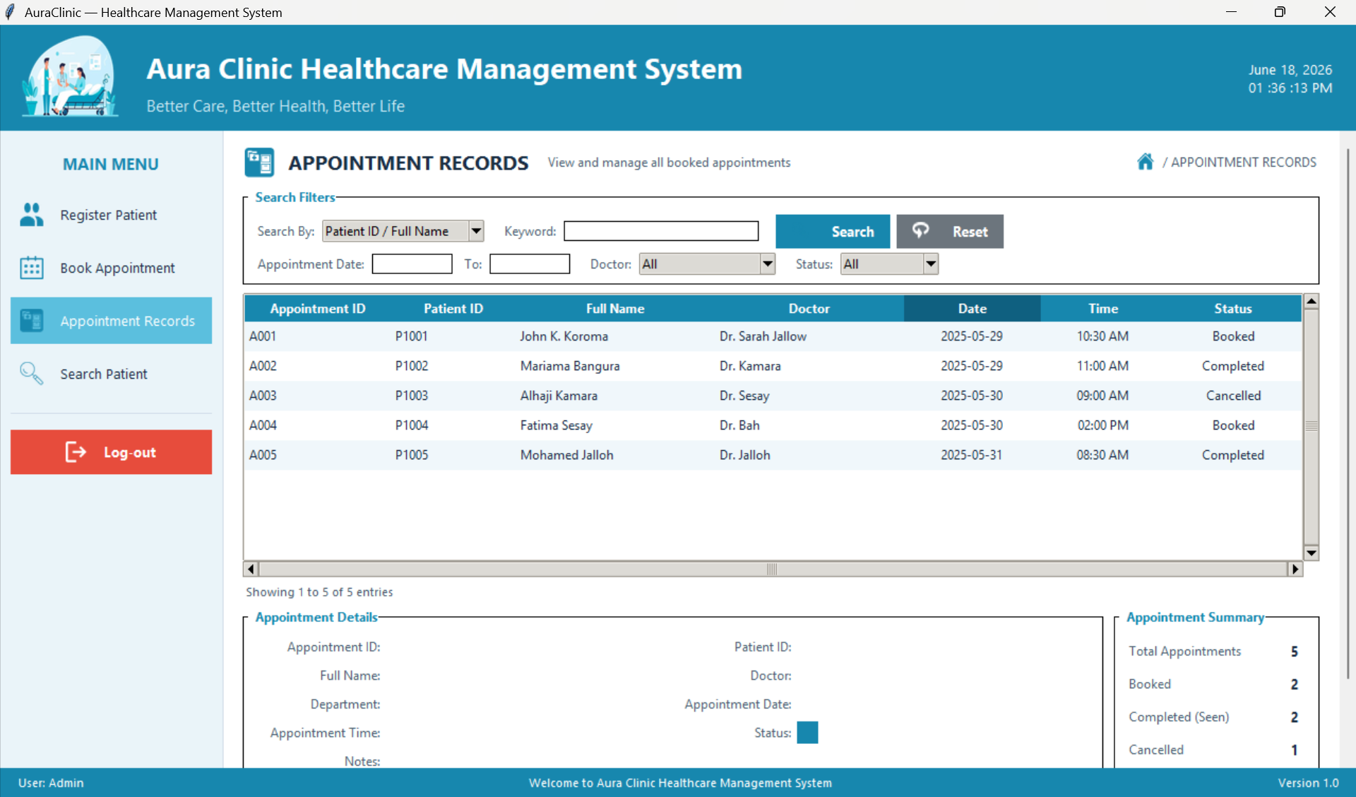
Screenshot 1 (Manage Appointment tab): This interface allows users to book, reschedule, cancel, or view statistics for appointments by entering patient and doctor details along with date and time.
Screenshot 2— Login Page
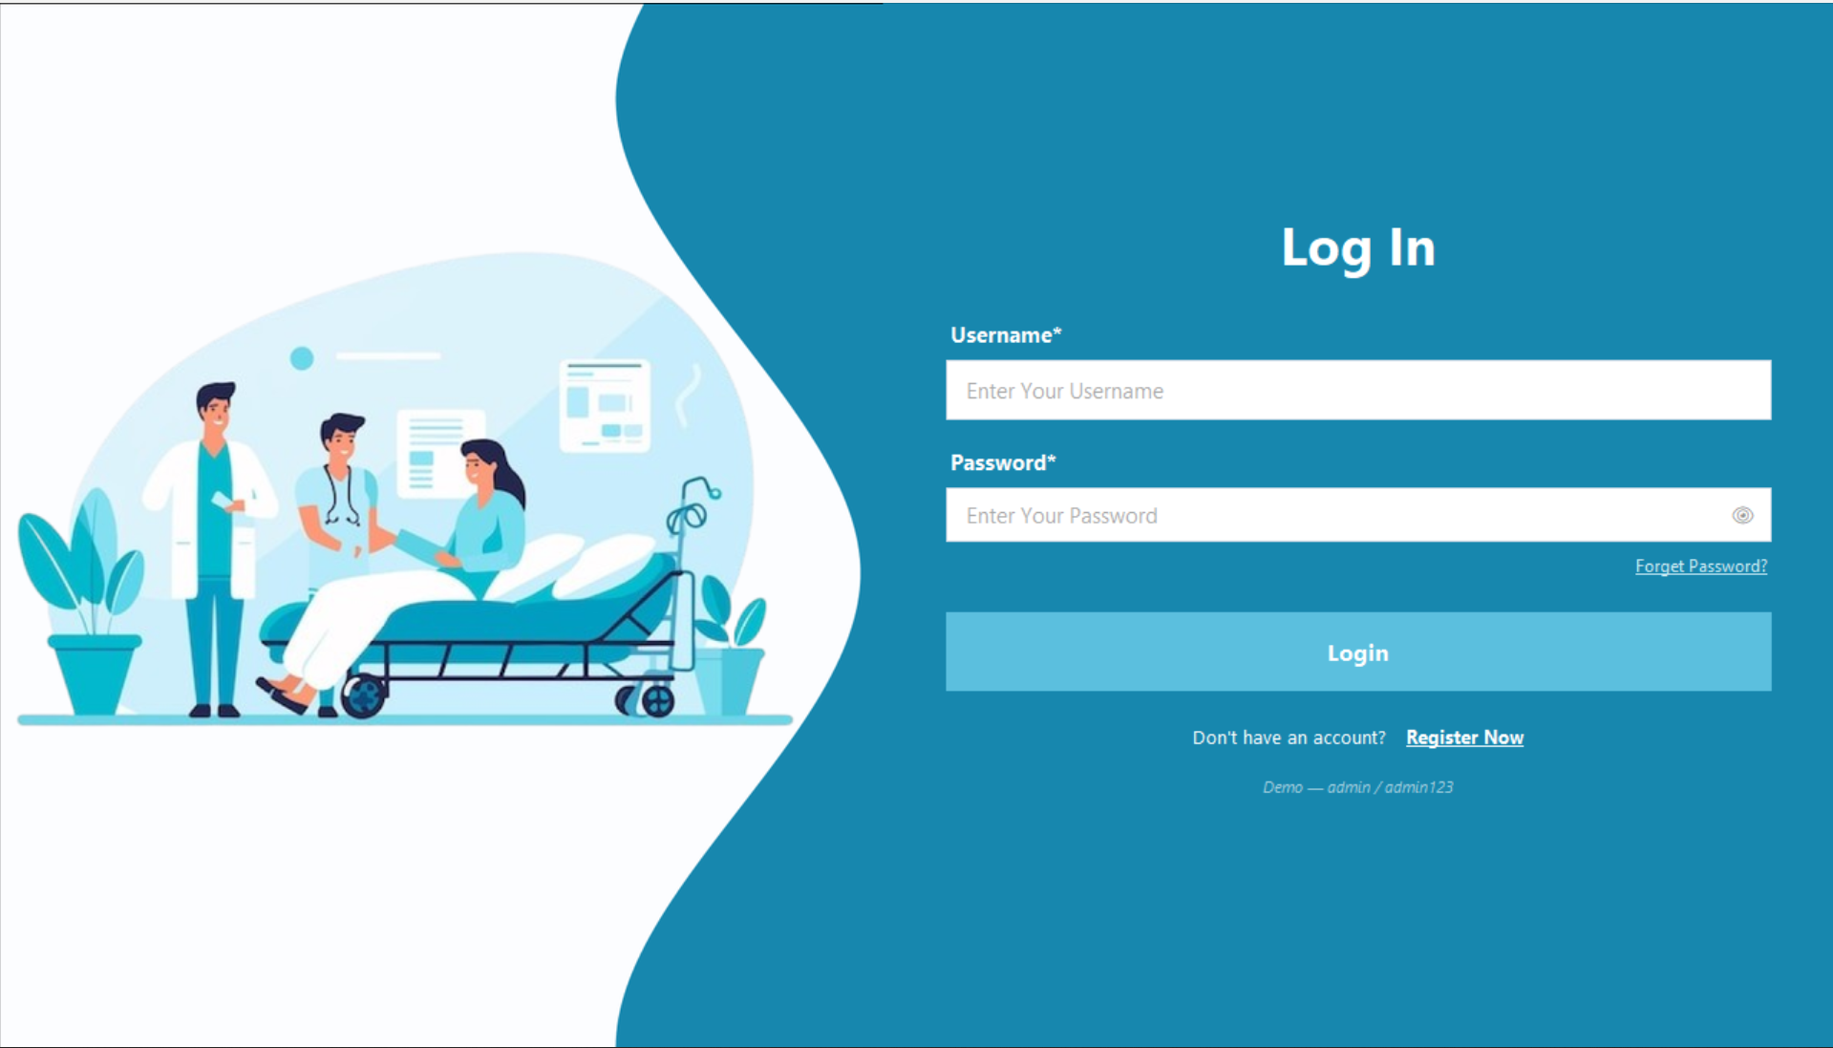
The login window uses a split-panel layout. The left panel displays the clinic illustration image loaded from Login page1.png in the same folder. The right panel contains the login form on a teal background. The form has a Username field and a Password field with a show/hide toggle button. A Forget Password link sits below the password field. The Login button turns a darker blue when hovered. At the bottom of the form a small hint shows the demo credentials for testing. When the correct credentials are entered, the login window hides itself and the main application shell opens in its place.
Two Screenshots of The Phyton Code
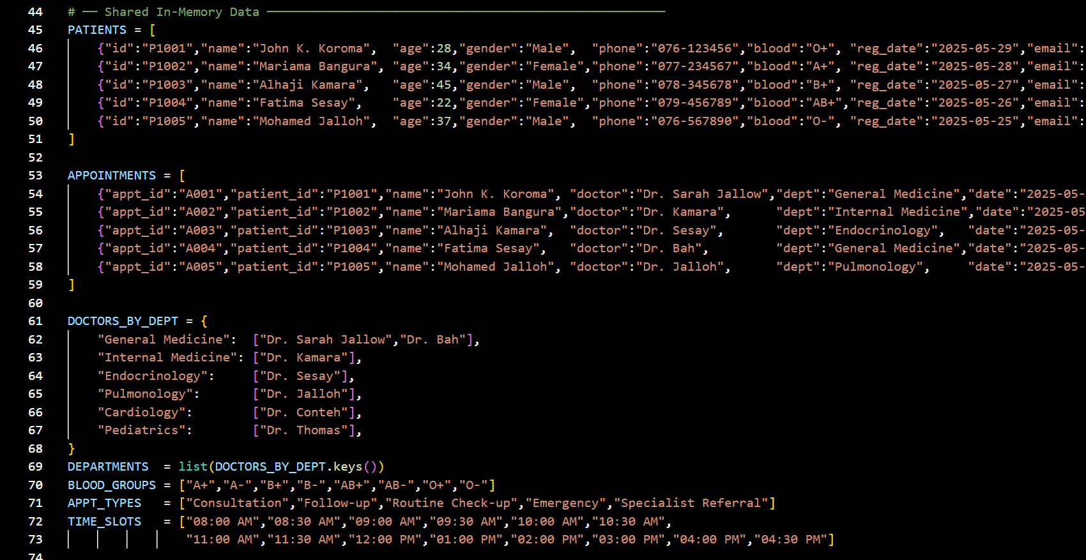
Screenshot 1: This code stores the hospital system data in memory using Python lists and dictionaries. It keeps information about patients, appointments, and doctors grouped by departments. It also creates lists of available departments, blood groups, appointment types, and time slots that the system can use when registering patients or scheduling appointments.
Screenshot 2:This function handles the user login process. It first checks whether the username and password fields are empty and displays warning messages if they are. It then verifies the entered credentials against the stored valid users; if they are correct, it opens the dashboard, otherwise it shows an error message and clears the password field so the user can try again.

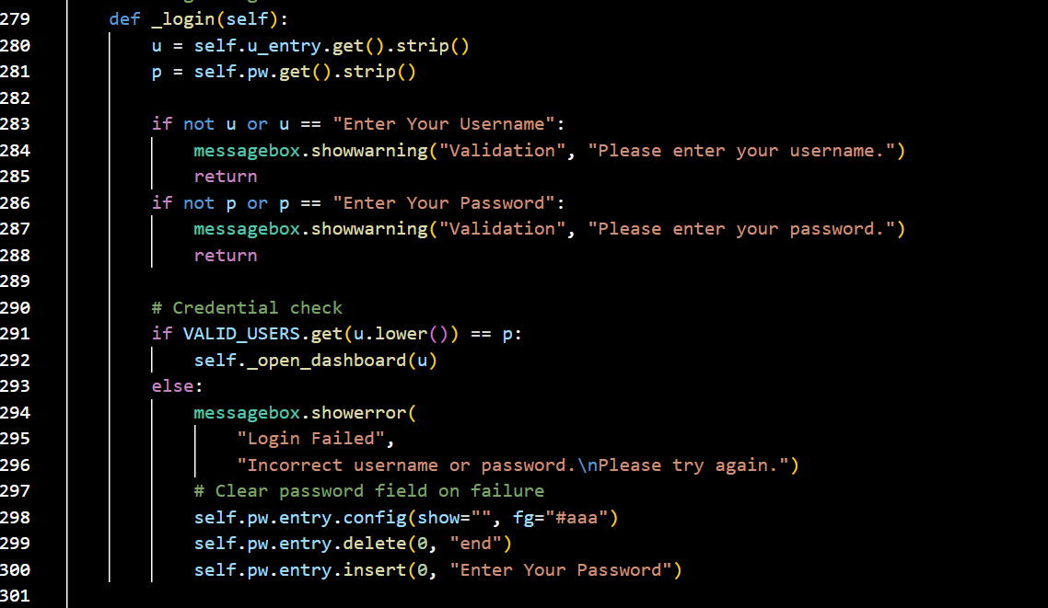

GITHUB EVIDENCE
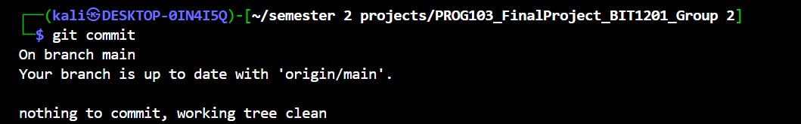
Git Commit

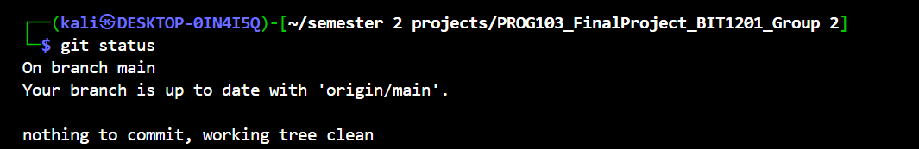
Git Status

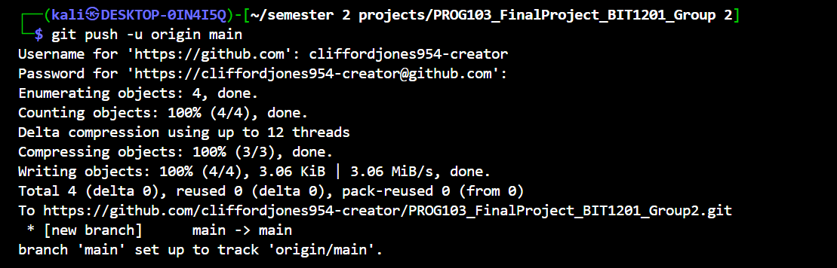
Git Push

Conclusion
The AuraClinic Healthcare Management System successfully demonstrates that structured programming principles can be applied to build a complete, professional-grade desktop application. Starting from a secure login page and progressing through four fully functional management pages, the system covers patient registration, appointment booking with conflict detection, appointment lifecycle management, and advanced patient search, all within a single navigable GUI shell.
The project applies every core concept from PROG103. Module-level constants enforce a consistent color scheme and layout across all pages. Appropriate data types are used for each field, with integers for ages, ISO strings for dates, and dictionaries for records. Decision structures validate every form submission and detect appointment conflicts before any data is written. Iteration populates every table and renders every time-slot button. Shared helper functions eliminate repetition and keep each page class focused on its own logic. Try/except blocks handle every image load and every potential runtime error. Object-oriented encapsulation keeps the four page classes independent of each other and independent of the shell that hosts them.
Beyond its technical merits, AuraClinic has genuine practical relevance. Its lightweight architecture, requiring only Python 3 and Pillow, makes it deployable in clinics with limited IT infrastructure, directly contributing to SDG 3 on Good Health and Well-Being and SDG 9 on Industry, Innovation, and Infrastructure. The modular codebase is also designed for future extension. Adding an SQLite database, user roles, or printable appointment slips would each require targeted additions rather than wholesale rewrites.
This project has strengthened our team’s understanding of GUI programming, event-driven design, shared application state, and the discipline required to write clean and maintainable structured code in a real-world context.

References
- Python Software Foundation, Python 3 Documentation, available at: https://docs.python.org/3/ (Accessed: 8 June 2026).
- SQLite Consortium, SQLite Documentation, available at: https://www.sqlite.org/docs.html (Accessed: 8 June 2026).
- United Nations, Sustainable Development Goals, available at: https://sdgs.un.org/goals (Accessed: 8 June 2026).

